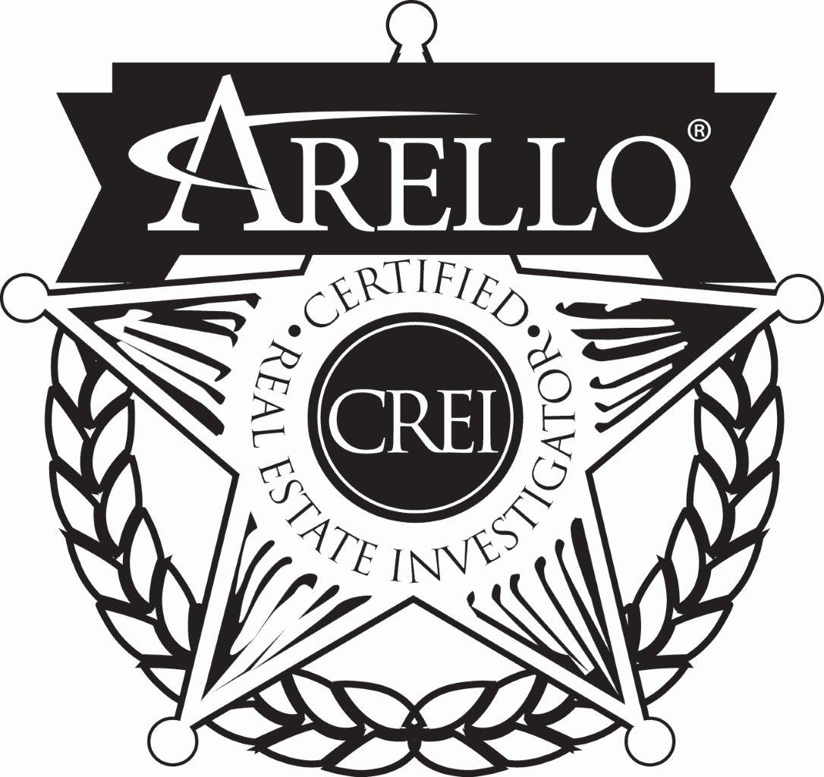
----------------------------------------------------------------------------------- CERTIFIED REAL ESTATE INVESTIGATOR
(CREI)
-----------------------------------------------------------------------------------
ARELLO® has created a respected designation that individuals earn to recognize their experience and expertise with real estate investigations and audits. New technology, laws, procedures and the increasing sophistication of investigations and audits require practitioners to perform at an ever-increasing level of professionalism.

Completion of ARELLO's basic course and attendance at least one ARELLO® Investigator Workshop are two of the requirements. Each applicant must also have completed a specified number of investigations and been an investigator for at least one year.

Certification benefits:
1. ADDITIONAL CREDIBILITY AS A WITNESS
2. GREATER RESPECT BY INDUSTRY PEERS
3. TANGIBLE RECOGNITION OF EXPERIENCE

Certification requirements/instructions:
1. Accumulate one year's experience as a real estate compliance audits and/or investigator.

2. Conduct at least 50 real estate compliance audits and/or investigations.

3. Complete the self-study program contained in ARELLO's "Investigator Training Manual" under the supervision and review of your supervisor, or complete the NCIT basic program of the Council of Licensure, Enforcement and Regulation.
Order the manual from ARELLO® ($30 US) at ARELLO, 150 North Wacker Drive, Suite 920, Chicago, IL 60606.

4. Attend an ARELLO® Investigator Workshop.
This event is held once a year. Go to ARELLO.org for information on the next seminar.

5. Prepare a case (with full documentation) for ARELLO® review.
Send the package to the current ARELLO® Investigator Training Board chairman at ARELLO® Headquarters.

6. Remit documentation and certification fee to ARELLO®. Send a check for $30 (US) to ARELLO® Headquarters.

Have your supervisor certify the information in #1, #2 and #3 in a letter to the Investigator Training Board Chair at ARELLO® Headquarters. Include copy of attendance certificate for #4.

If you have any questions, contact Lynette Hodges, Director of Distance Education at lynette@arello.org or 312.300.4805. Address: ARELLO Headquarters, 150 North Wacker Drive, Suite 920, Chicago, IL 60606

Begin this rewarding career development process today!

